HCA C Sharp Training Day 05 Assignment Solutions
Assignment 1:
Answer:
var summary =
db.Claims
.AsNoTracking()
.GroupBy(c => c.Status)
.Select(g => new
{
Status = g.Key,

ClaimCount = g.Count(),

TotalBilled = g.Sum(x => x.BilledAmount),

TotalReimbursed = g.Sum(x => x.ReimbursedAmt),

Gap = g.Sum(x =>
x.BilledAmount - x.ReimbursedAmt)
})
.OrderByDescending(x => x.TotalBilled)
.ToList();

var revenueAtRisk =
db.Claims
.AsNoTracking()
.Where(c => c.Status != "Paid")
.Sum(c => c.BilledAmount);

Screenshots:
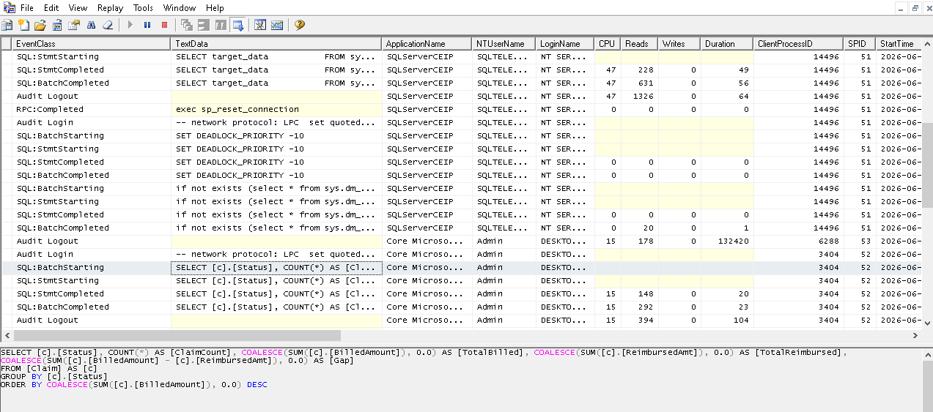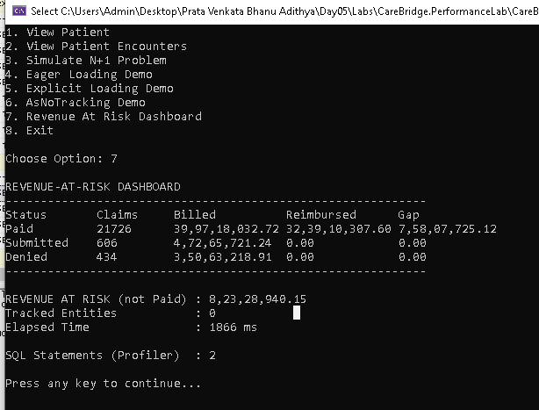

Assignment 2:
Answer:
- Cartesian Explosing Demo
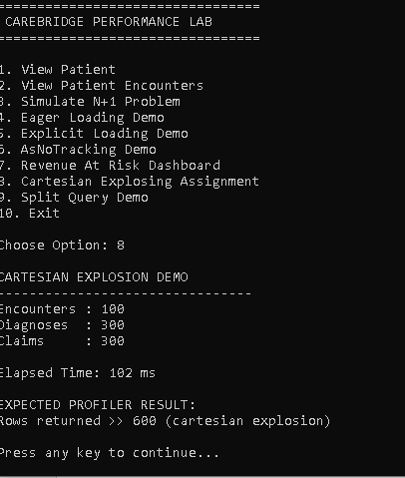
- Split Query Demo
